Nicolas Moy
DSCI 551
Semester Project Report
Intro: For my semester project, I chose to do the SQL option by myself. I ended up completing the project requirements of implementing CSV parsing and an in-memory data frame with SQL like operations, all without pandas, csv, and other prohibited libraries. I also finished the application using the Streamlit library that demonstrates these functions. I chose the theme of my project to be a NBA data analysis app since my love for basketball and sports had been incredibly strong since before I can even remember. I specifically focused on my favorite team the Golden State Warriors and the 2022/2023 season which was the season after they won the Championship.
Dataset: My datasets for the project were 2 CSVs. I got these CSV datasets from both the NBA API and Kaggle’s website. The first CSV is “WarriorsStats.csv” which consists of the 16 warriors players from that season. This was my dataset with all the statistical numbers that is mainly used for the analytical functions. The columns consisted of player id, full name, position, games played, per game stats (minutes, points, rebounds, assists, steals, blocks, turnovers, fouls) field goal pct, three point pct, free throw pct, age, and salary. The second CSV is “Player.csv” which was a list of all the active and inactive players in the NBA. It consisted of an ID column (every NBA player has a unique ID given to them when joining the league), full name, first name, last name, and is active columns. These 2 datasets connect with the IDs since those values are unique and the basically the primary key of each dataset. These 2 datasets have a good variety of datatypes and were fun to work with.
Data loading and Parsing: My project code starts with my function for data loading and parsing. My loading function uses .readlines() to read all the data and everything coming in from .readlines() comes in as a string, but we need the other python datatypes to manipulate the data. So I have a helper function for the loading called convert_value. This function takes in the value and first removes any whitespace with .strip(). Then it removes any quotes if there are any present from the csv file wrapping text fields. Then the datatype value detection begins. The function uses .isdigit() to check if the value is a number. If there any “.” in the value, then it is a decimal value so it will convert to a float type. And if the value is true or false the function will put the value as a Boolean type. Finally if none of those checks pass, then the value will be defaulted to a string type. Now that the datatype conversion is handled, my main loading function is called load_csv with the parameters being csv_file and the separator variable being a comma since I am working with comma separated value files. Like I said earlier I open the files with .readlines(). I start with initializing an empty dictionary and storing the first line data (which is the column names) into the dictionary as the keys. Then the rest of the actual data rows, I use .strip() and .split() to get each individual data value that is run through my convert_value function to store it as its proper data type.
Convert_value and load_csv functions:
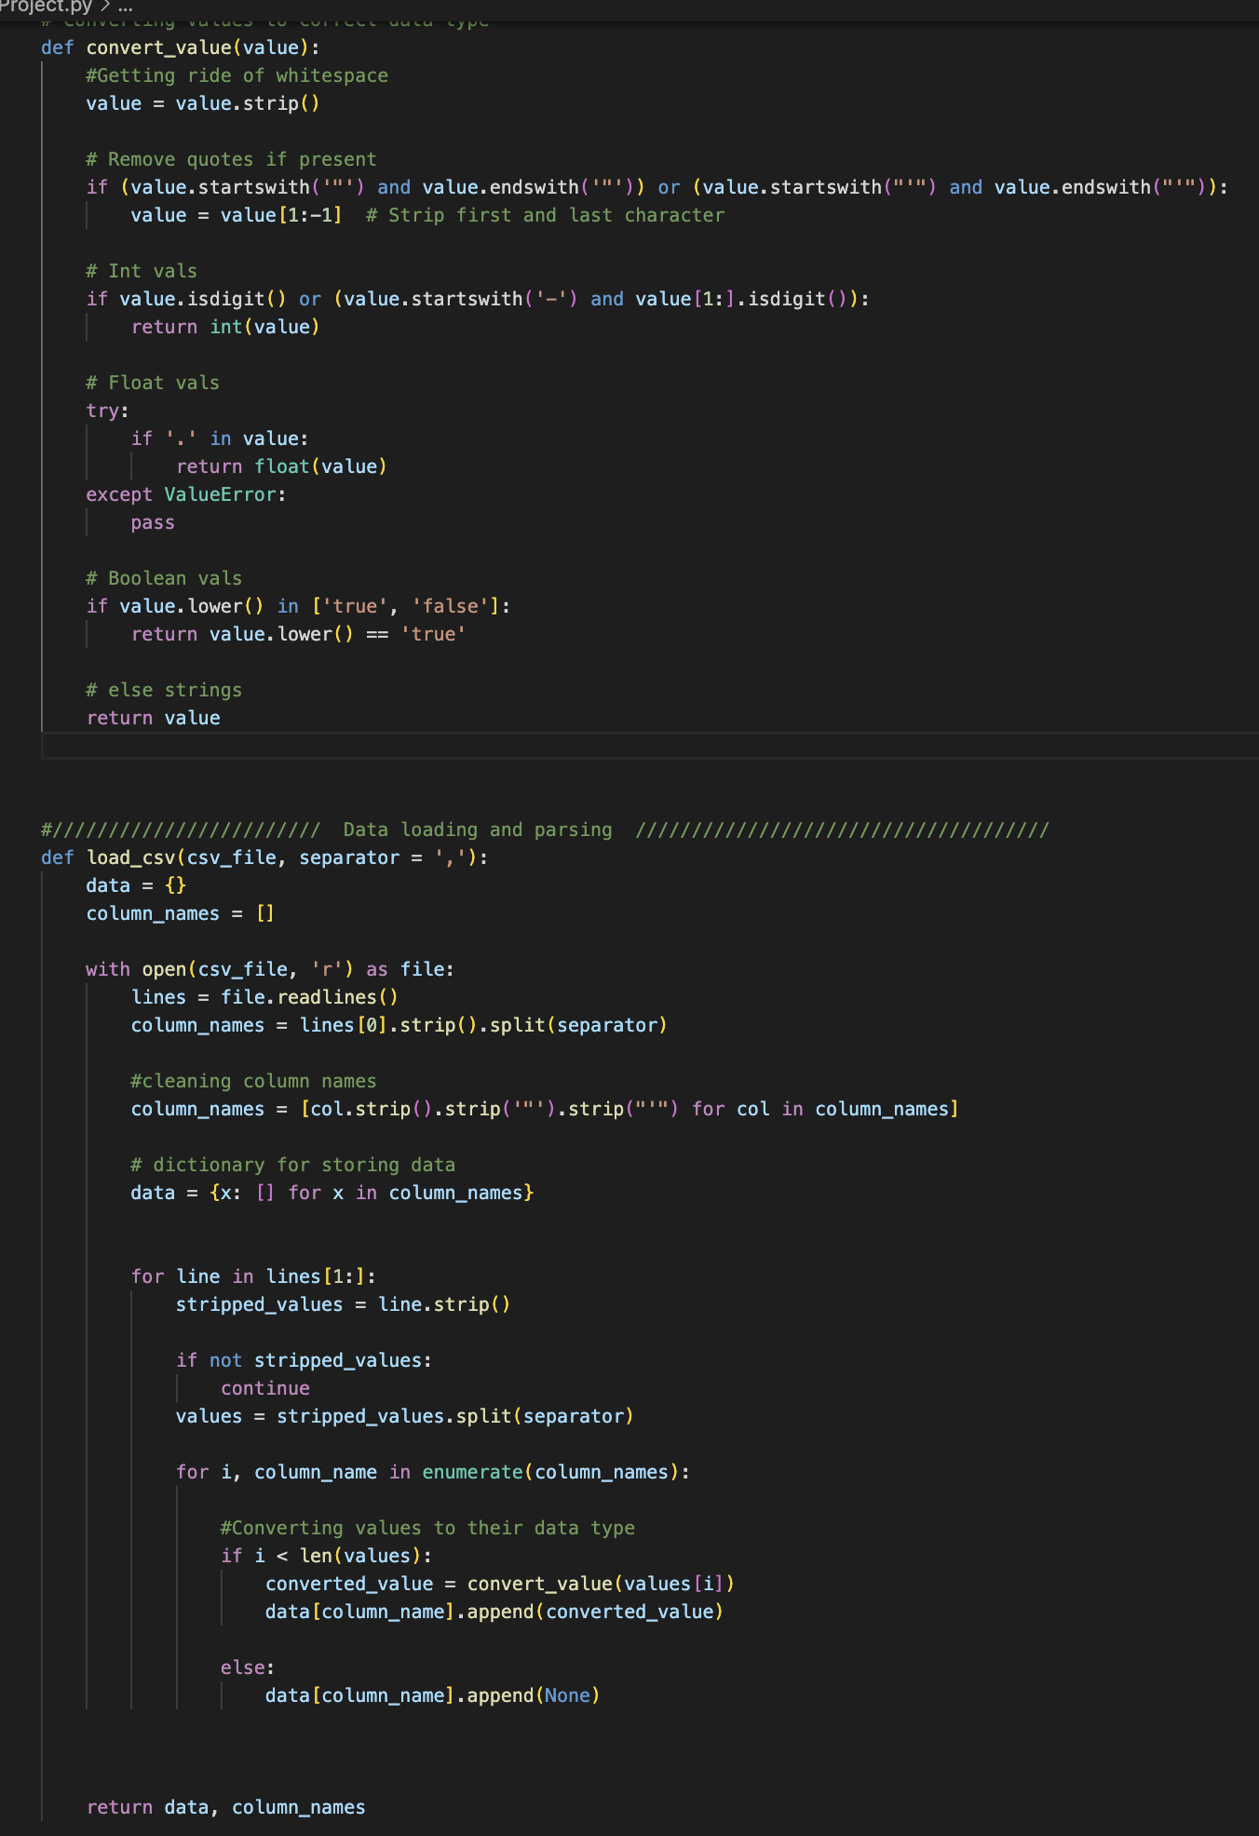
Application: For my application I chose to use the Streamlit library to create the app. It is an interactive dashboard that takes in the 2 CSV files and then has a dropdown menu where the user can apply the SQL functions. I chose Streamlit since it can make the entire application in python with no JS or CSS needed. It uses all my functions imported from the Project.py file. It starts with using load_csv in the sidebar part of the code where player.csv and warriorsstats.csv are submitted and loaded into 2 separate dataframe objects. It uses Streamlit session state which tracks the user’s current session, so the program loads the data once and doesn’t have to reload for every operation. When the data is loaded and you’re in the main homepage, you have a data preview that shows the columns and the first 10 rows of data using the __str__ method. The first operation is the SELECT function where the application calls the df.select method. You can choose which columns to project and then those columns are displayed along with the line of code that runs the select operation. The next operation is the WHERE function where the app calls the df.where method. This operation has 2 choices where the user can pick simple filtering or a conditional filter. The basic filter is dictionary-based filtering looking for an exact match, while the conditional filter uses a lambda function to do numeric comparison with <, >, <=, >=, and ==. In the AGGREGATION operations, the user has the option to choose an aggregation function (MAX, MIN, SUM, AVG, COUNT) and which column to group by, then the app will run whichever corresponding method that was chosen. Finally the last operation is the JOIN operation. The user specifies which columns to join the data on, and in my project I use the player IDs. After the app calls df.join, the result is the combined data of the 2 csv files. Overall, I think my app has a clean layout that is easy to follow and informative.
Application Pics:
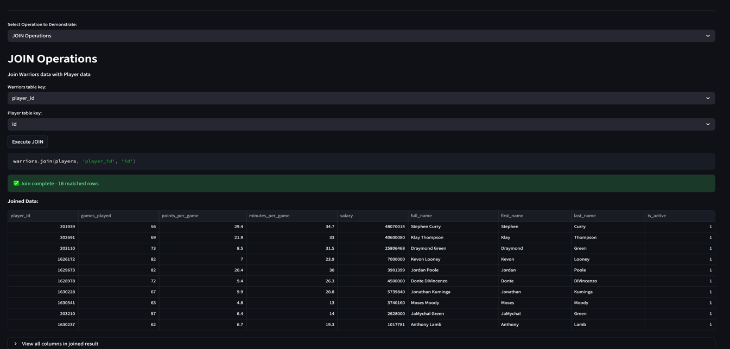
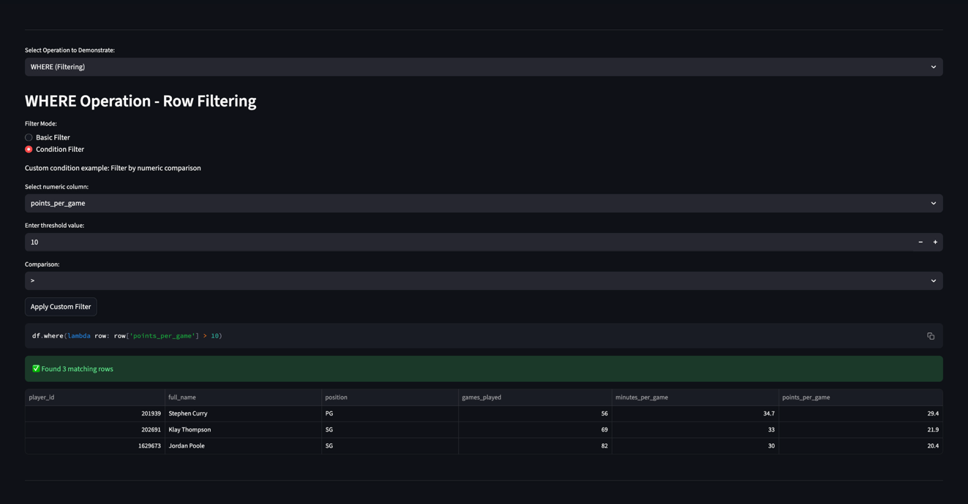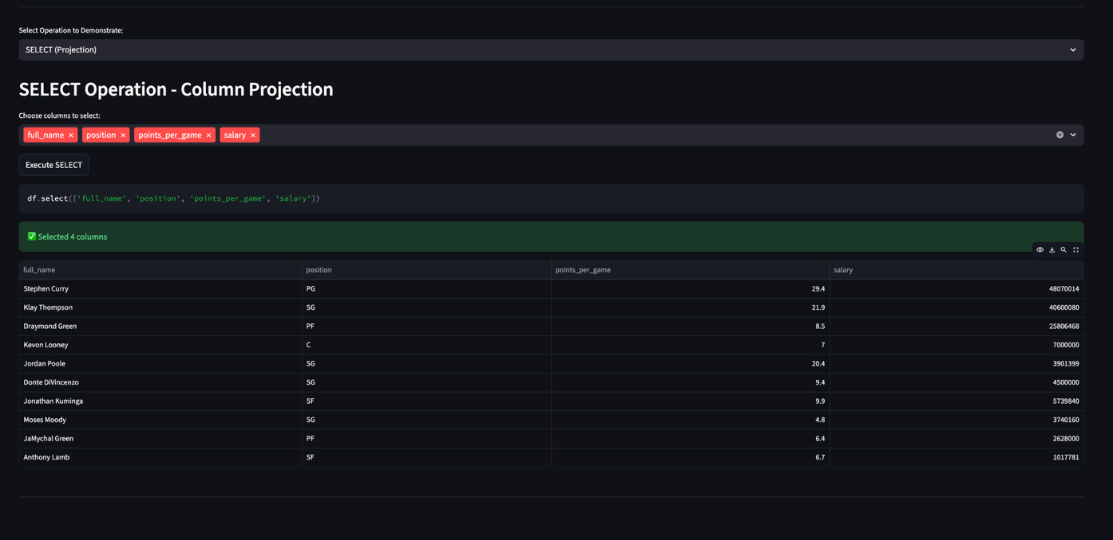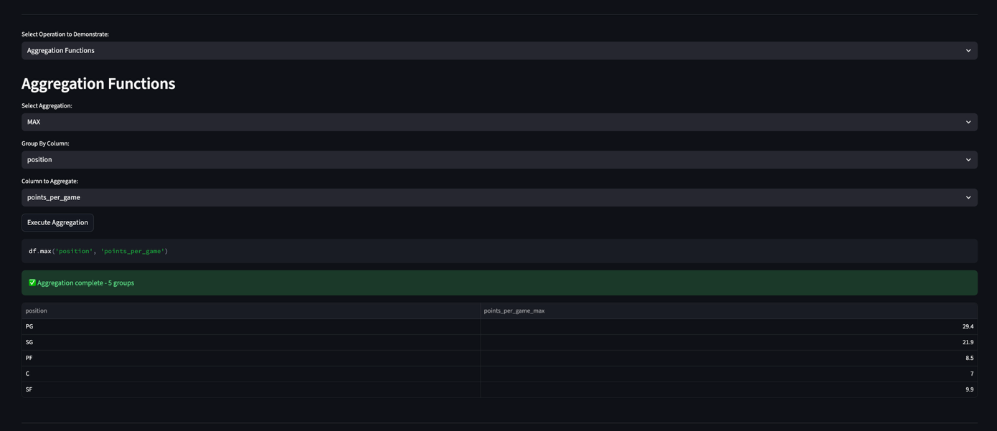
Dataframe Class and SQL Operations: The heart of my project, the DATAFRAME class. The dataframe class is initialized with a data dictionary, the column names, and a shape tuple that tracks the rows x columns of the dataframe. The dataframe is column oriented, where the columns are stored as dictionary keys and the dictionary values are the column data in python lists. I have 2 helper functions (__getitem__, __str__) for the dataframe class that allow me to have column access (bracket notation) to the data and allow me to print the dataframe. Like we discussed in class, using the strategy with direct dictionary lookup is very efficient. I chose to have all the SQL operations be methods of the class. For the SELECT operation, I just looped through the columns and checked if the requested columns existed. Then if they do exist, I add the data from the specific columns to a new dataframe and then return the new dataframe that has just the selected columns. For the WHERE operation, I first checked to see if the dataframe is empty or not. Then I make a row dictionary that’s temporary but makes accessing the values easier since I can access them by column in this new row dictionary. I have 2 condition types for the filtering: lambda function and dictionary matching. If the input is callable aka lambda, then the row dictionary gets passed to the function and the rows that return true are kept. If the input is a dictionary, then I loop through each key-value pair in the dictionary checking if the values match. Like select function, the result of matched rows are returned as a new dataframe. For the aggregation, I need the GROUP BY function first to use in all the different operations. The group by function starts with confirming all the columns to be grouped exist and are in a python list. Then I loop through each row in the dataframe, getting the values from the grouping column for that row. Next a group key is made and if the function is grouping by a single column, the key is just that value. If the function is grouping by multiple columns, the key is a tuple of those values (tuples are hashable so they can be dictionary keys). If the key doesn’t exist I make a new list for it and if it does exist then it gets appended to the existing key list. Finally the group by function returns a dictionary of all the groups. It doesn’t actually return any data, just row indices. This results in more efficiency since the aggregation functions only pull the required indices the need. The AVG, SUM, MAX, MIN, and COUNT functions are all pretty similar. In each of the functions, they first run the group by function to determine the chosen groups. Then for each group key and row index it extracts the relevant values, performs the respective aggregation, and returns a new dataframe with the aggregation complete. Now finally the last operation I did was the JOIN operation. My join implementation was an inner join so it only joined on matches found in both datasets. First my join function starts with validating the given join keys exist. Then I initialize an empty list for the resulting columns and empty dictionaries for the result data and the changed columns (conflicting column names). I build the result list of columns with the left and right dataset columns (skipping the right key for no duplicates). If there’s a column in the right dataset that already exists in the left dataset, I added a “_right” to its name to avoid this name collision. Next I have a nested loop to find the matches. The outer loop goes through each row in the left dataset, getting the key value for the row, then iterates through the right dataset in the inner loop checking each row for matching values. If a match is found, then the data from both rows is put into the result dataframe and this result dataframe is returned.
Dataframe and SQL operation functions:
: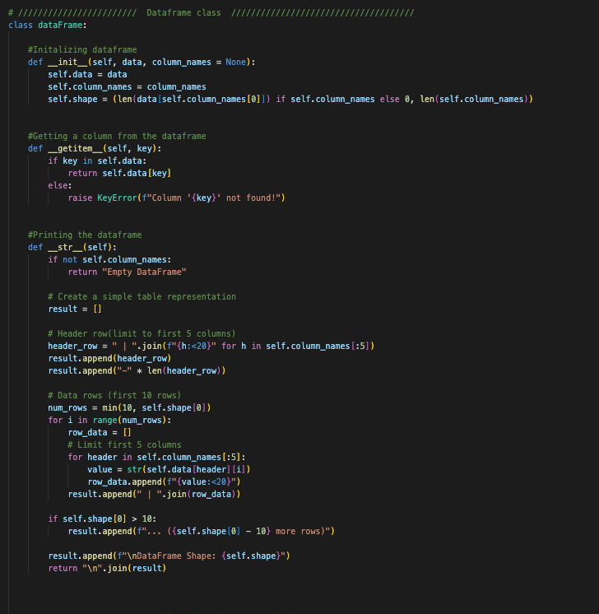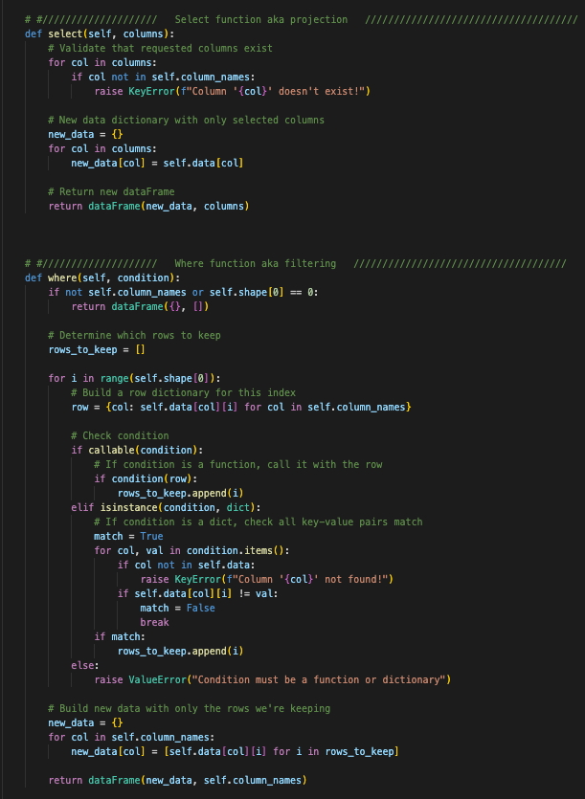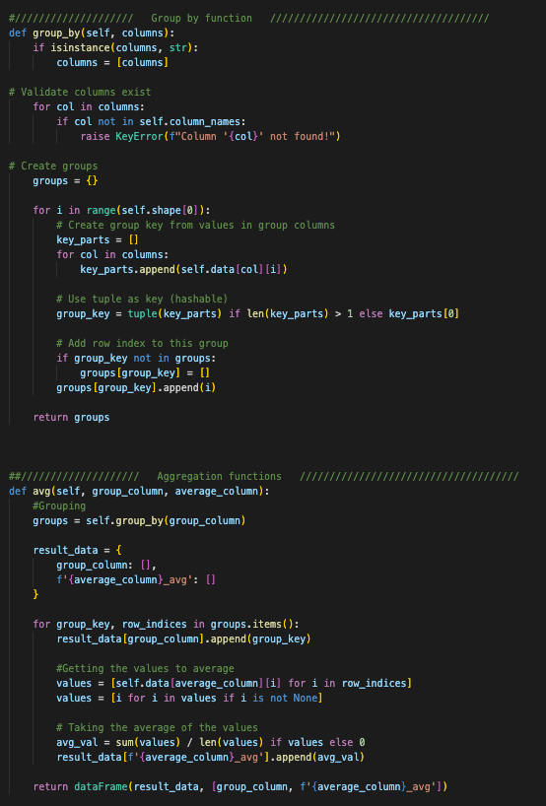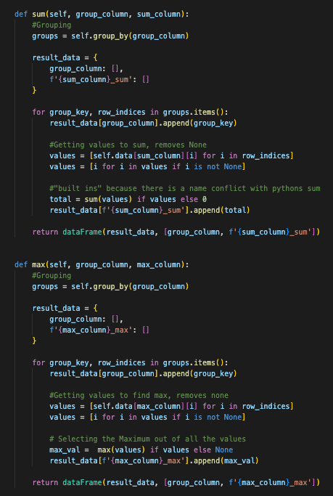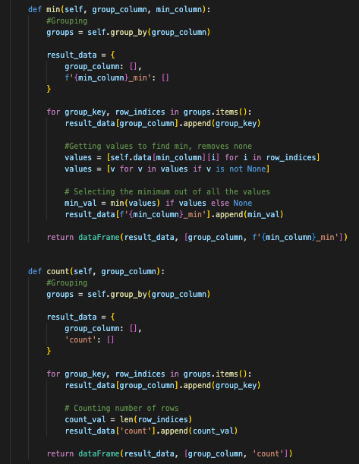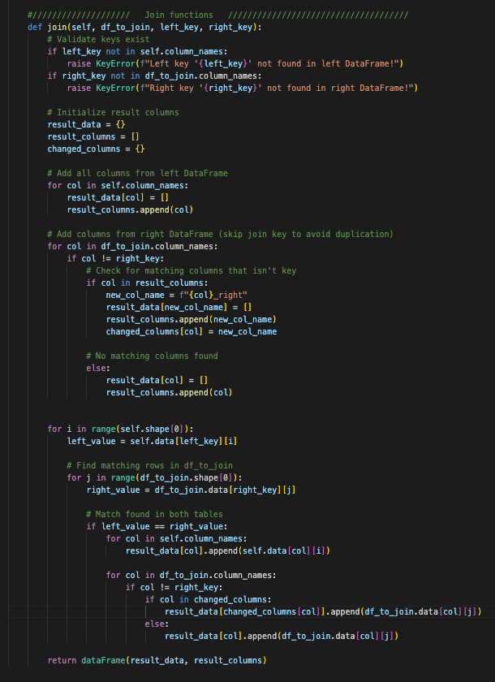
What I’ve learned: Throughout this project I got to learn a few things. I first gained a lot of respect and appreciation for the people who create python libraries. Not being able to just import what I need was challenging and I can imagine all the work and complexity that goes into creating robust libraries. I also learned that the pandas and csv libraries must have very complex and strong type conversion and error handling. Another thing I’ve learned is that I have a new least favorite SQL operation which is join. Doing the join operation was the most challenging throughout the project. I had a hard time trying to figure out how to handle conflicting columns during a join operation, ultimately deciding to add a “_right” column to the resulting data from the column that was conflicting originating in the right dataset. I also found it easier to separate the group by functionality into its own function. At first, I tried to do the grouping code in each aggregation method itself, but I found it made more sense and felt cleaner to have a separate function for the grouping code and just call that function in each aggregation method. Dealing with real world data isn’t perfect which I knew but I got a reminder during this project with my dataset having inaccuracies with the player IDs. When trying to solve the join operation, I had a lot of extra time spent debugging thinking my code was wrong, but the data was inconsistent. I was getting incorrect matching because the player csv from Kaggle had incorrect player ids for some of the warriors’ players. So I learned that even if the data is from a reputable source, it can still be messy/incomplete. Another thing I learned is that doing UX/UI isn’t as easy as it seems. I was stressing over how to make my app looks, how complex/simple it should be, and how to present it in the most informative and effective way. I learned many things from this project and with my future hopes in ML, I know this experience of parsing and handling data will help me down the line.

